

**FUTURE INSTITUTE OF ENGINEERING AND MANAGEMENT**

**CC – 148**

**UNDER**

**MAKAUT, WB**

## MINI PROJECT REPORT

**DRIVERS ANTI SLEEP DEVICE**

**PRESENTED BY**

## SUPRATIK BHATTACHARYA (14800320016)

## SK YEAS ZIDAN(14800320048)

**B.TECH(ECE)**

**6TH SEMESTER**

**Academic Year: 2022-23**

# TITLE: DRIVERS ANTI SLEEP DEVICE

## ABSTRACT

This paper aims to create a framework to keep the car safe and secure through critical activity. When we run in ignorance we cannot take care of our own. If we make all vehicles with an automatic safety system that gives the driver a high level of protection, an alarm will also be issued. The device has an installed a eye blink sensor. Once the driver has started the engine, the sensors automatically detect the blink of eye. On this device the output of the sensor is provided for comparison with ARDUINO. When the value reaches the set level, the buzzer automatically vibrates, the LED glows, and the car stops automatically when eye blink sensor receives a signal from the transmission module.

**Keywords:** Arduino, Eye Twitch Sensor, Led, Dc Motor.

## INTRODUCTION

The failure of drivers in any vehicle incidents is a very important part of the dangerous problem facing the community. It can cause serious accidents for a variety of reasons and sometimes fatal as most drivers are out of control. Various things involved in car crashes such as high speed, sleep while driving other distractions such as texting while driving, talking to others, playing with children, etc. Citizens are aware of dangerous drive cars but do not understand the level of driving. fatigue. About 1374 people die every day, and about 400 people die. Approximately 57 road accidents and 17 deaths per hour as a result of motor vehicle accidents. In car accidents,

54.1 percent are between the ages of 18 and 34. The Government of India, the Department of Border Transport and the Department of Highways are planning to reduce the number of road accidents and fatalities by 50 percent by 2022. Globally, car accidents have proven to be one of the world's biggest security concerns. In 2015 about 5 lakh road accidents occurred in India. A tired driver is not able to steer the car by those who are sleep at work, he is unable to take adequate steps leading to an accident so it is necessary to monitor the driver's drowsiness to avoid accidents. We focused on this issue using the eye twitch sensor to introduce a car accident prevention program. This paper examines the detection of various collisions and the reduction of such a system.

## SYSTEM DESCRIPTION

Embedded system devices are an important part of daily life. These are a combination of hardware and software, in which software is commonly known as hardware embedded software. One of the most important features of these systems is that they provide o/p within time limits. So we often use embedded systems on simple and sophisticated devices as well. In many devices like microwave, calculators, TV remote control, home security and crowded control systems, embedded system applications are very much involved in our real life. Embedded system block diagram is shown in Fig 1. Embedded devices are widely divided into several categories, depending on the hardware and software and the microcontroller "8 or 16 or 32-bit".

## SYSTEM DESIGN IMPLEMENTATION

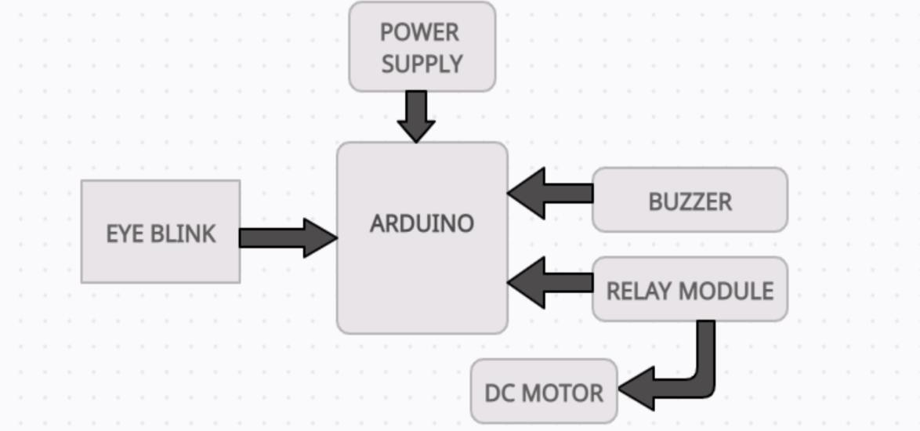System block diagram is comprise of: Eye blink (IR): related to sleep detection and alert the driver with the components used in the proposed operation are Eye blink length and frequency, Power supply, Buzzer, LED ARDUINO (UNO), Relay Module, DC as shown in Figure 2. The main component is Arduino Uno which is an ATmega328 based microcontroller (MC) that performs all functions related to controlling the embedded system circuit. The blinking module works by illuminating the eye area with infrared light, and then detecting changes in scattered light using an image transistor and a separation circuit. Each of the components is described below.

Figure 1 : Schematic Block Diagram

## MAIN COMPONENTS

### ARDUINO(NANO):

### IR SENSOR:

### BUZZER:

### MOTOR(DC):

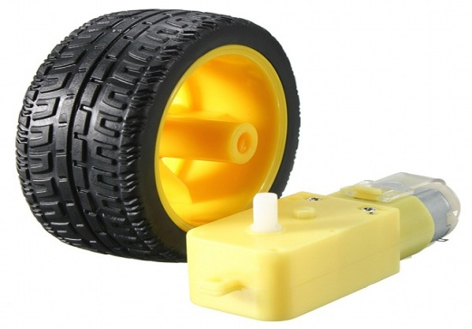

## ARDUINO CODE

void setup() {

Serial.begin(9600);

pinMode(13,OUTPUT);

pinMode(11,OUTPUT);

pinMode(10,INPUT);

}

void loop() {

long s1=digitalRead(10);

Serial.println(s1);

if(s1==HIGH)

{

delay(3000);

digitalWrite(13,HIGH);

delay(1000);

digitalWrite(11,LOW);

}

else{

delay(500);

digitalWrite(13,LOW);

digitalWrite(11,HIGH);

}

}

## DESIGN ANALYSIS AND RESULT

The system works with the goal of the eye twitch sensor that receives the driver's sleep. This effect is given to the buzzer. The rotation speed is reduced when the driver is sleep, while on the other hand the blink sensor receives the sensor stops the wheel. This program offers a new way to stop drowsy men. The device has an installed blink sensor. Once the driver has started the engine, the sensors automatically detect the blink of an eye and check the his or her breath. The process is depicted by the flow diagram shown in fig 7. On this device the sensor output is given to compare with ARDUINO. If the value exceeds the limit when the buzzer automatically generates vibration, the LED glows and the car stops automatically.

### Methodical Steps for execution:

Connect DC motor to relay and give relay connection to the Arduino pin A0. Now dump the code into Arduino using USB cable Connect USB cable to pc and open arduino software, enter the code and compile & run then select the arduino port and click upload button then your code will be uploaded into arduino. Now connect the batteries and check the output of eye blink sensor. If blink of eye is more than 2 seconds car (motor) will be stopped. The proposed work is completely illustrated below.

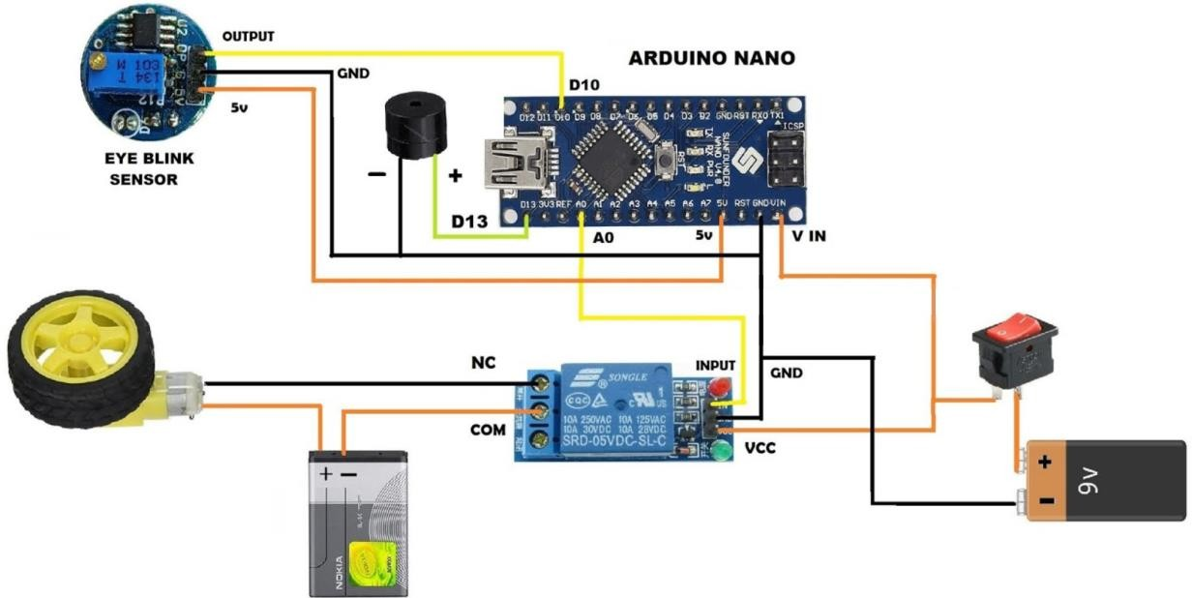

## WORKING PRINCIPLE

This system alerts the user if he/she falls asleep at the wheel thereby, avoiding accidents and saving lives. This system is useful especially for people who travel long distances and people who are driving late at night.

## FUTURE SCOPE

The future works may focus on the utilization of outer factors such as vehicle states, sleeping hours, weather conditions, mechanical data, etc, for fatigue measurement. Driver drowsiness pose a major threat to highway safety, and the problem is particularly severe for commercial motor vehicle operators. Twenty-four hour operations, high annual mileage, exposure to challenging environmental conditions, and demanding work schedules all contribute to this serious safety issue. Monitoring the driver’s state of drowsiness and vigilance and providing feedback on their condition so that they can take appropriate action is one crucial step in a series of preventive measures necessary to address this problem. Currently there is not adjustment in zoom or direction of the camera during operation. Future work may be to automatically zoom in on the eyes once they are localized.

## CONCLUSION

People are increasingly exposed to dangers today. Therefore, we need to take action against this as an engineer and have the solution we need. Any automation is designed to protect a person. Such a model is tasked with developing a system for diagnosing and controlling the speed of vehicles to prevent accidents. To some extent, modern technology offers some hope of stopping these. This paper includes monitoring the blink of an eye with the help of an IR sensor. On this device the output of the sensor is provided for comparison with ARDUINO. When the value reaches the set level, the buzzer automatically vibrates, the LED glows, and the car stops automatically when the eye blink sensor receives a signal from the transmission component.

#### Participant Signature …………………………………………

#### Participant Signature………………………………………... Examinee Signature………………………………..

#### Signature Date : Signature Date :